**Floral Abstract Rectangular Frames with Gingko Leaves**

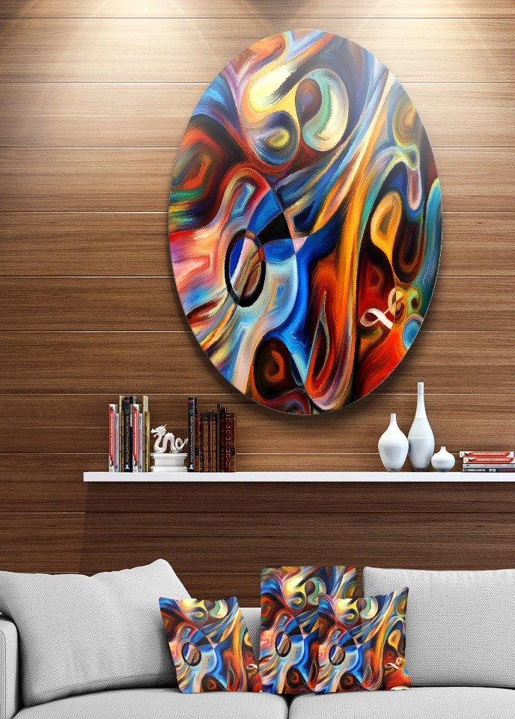Floral abstract rectangular frames with gingko leaves bring a touch of natural elegance and artistic charm to any interior. These designs typically feature delicately crafted gingko leaves, known for their unique fan-like shape and symbolic association with longevity and resilience. Encased within sleek rectangular frames, the composition balances modern geometry with organic beauty. Often finished in metallic tones like gold or bronze, these art pieces exude sophistication and complement various decor styles, from contemporary to transitional. Perfect for living rooms, dining spaces, or bedrooms, they serve as timeless accents that add depth and tranquility to your space.